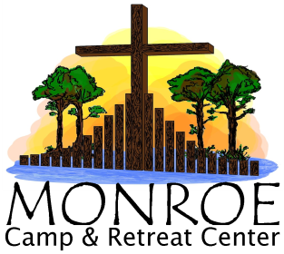 | MONROE CAMP AND RETREAT CENTER  RESERVATION REQUEST FORM  24501 Camp Road, Laurel Hill, NC 28351  (910) 276-1654 Fax (910) 276-0422  www.monroecamp.org

The Reservation Request Form is designed to collect basic information from groups wishing to use Monroe Camp and Retreat Center facilities. Please read the attached camp use policies before completing this form. Direct questions to the Camp office at (910) 276-1654.
Date(s) Requested (mm/dd/yyyy): Arrival Date _______________ Time_________ Departure Date _______________ Time _________
Group Name:
Contact Person: __________________________________ Contact Email:
Contact Home Phone: ____________________________________ Contact Cell Phone: ______________________________________

Bill To:
Address: ___________________________________________________ City, State, Zip: ______________________________________
Day Phone: ____________________________________________ Evening Phone: __________________________________________
Name of Event/Activities Planned: ___
Number attending Event: Males ____________ Females ___________ Total: ________________
Use of Swimming Pool and/or Lake: Persons using the camp facilities are invited to use the swimming pool (when in season) and the lake for canoeing. Please refer to the lifeguard policy before answering the following question.

Check one of the Following: ____ We will use Camp Supplied Lifeguards ____ We will Supply our own Lifeguards.
(1 lifeguard required per 20 people for pool, 1 lifeguard per 25 people for canoes)

TOTAL FOR ALL SERVICES (From Page 2) $_________________________

Less Deposit (50% of above TOTAL but not less than $50) $_________________________

Balance Due ten (15) business days before event $_________________________
By signing below, the applicant signifies that the group requesting use of camp facilities and services agrees to abide by all camp policies pertaining to MCRC. Reservation requests will be considered upon receipt of this completed and signed form, a deposit check in the amount shown above and the submission of all other required documentation (ex. “Food Selection Form(s)). Once this reservation is confirmed, I understand that my group is subject to all of the MCRC’s cancellation/refund policies.
Reduction in numbers may be adjusted until 14 days prior to event. Addition to numbers will be allowed based on availability until day of the event.
CANCELLATION POLICY: Cancellations of more than 60 days before first day of use shall recover full fees minus a $50 processing fee. Cancellations made 30-59 days prior shall lose 25% of the total fee or $50 whichever is greater. Cancellations made up to 15 days prior to scheduled use shall owe 50% of the group’s reservation cost on file on date of cancellation. Cancellations made within 14 days of the event shall owe and pay full cost.
Group Representative Signature___________________________________________ Date______________________
Camp Representative Signature___________________________________________ Date______________________
Return completed Forms & Payment to: Registrar at Monroe Camp & Retreat Center, 24501 Camp Road, Laurel Hill, NC 28351

