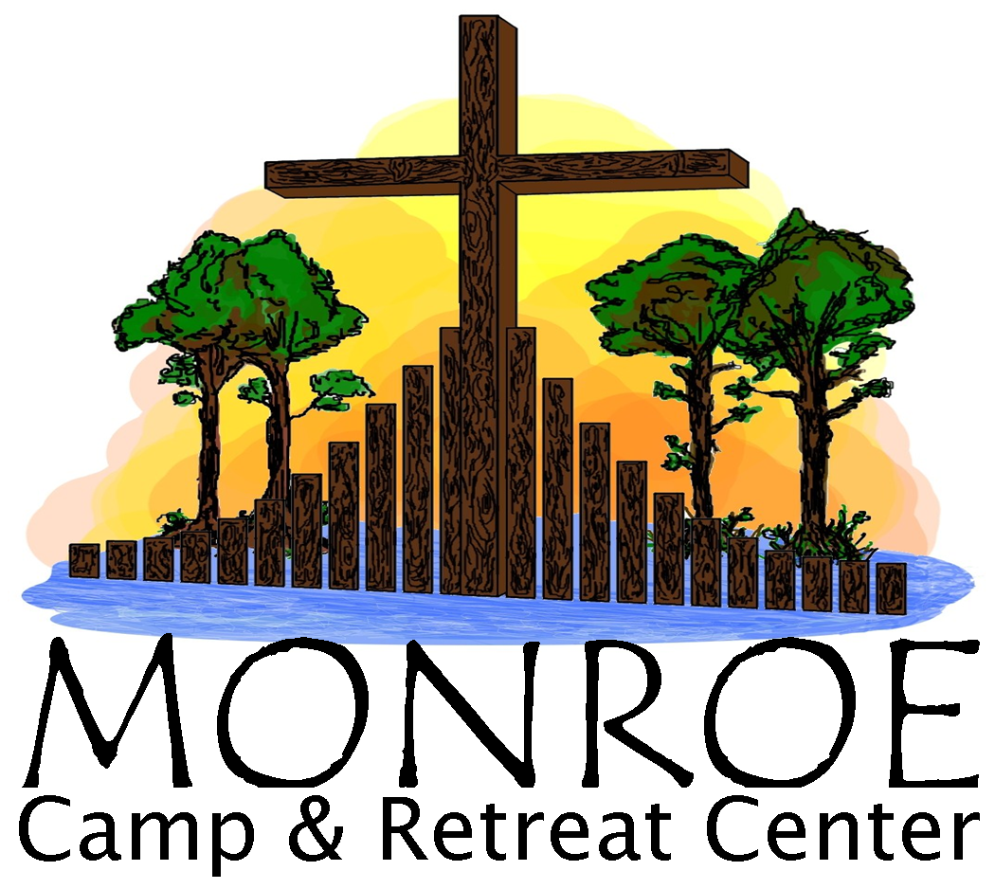 Event Registration Form

**Your Information:**

Last Name: _____________________________________________________ First Name: ______________________________________________

Male ________ Female ________ Birth Date: ______/______/______

*If registrant is under 18, name(s) of parent/guardian(s): _________________________________________________________________________

Address (Street or Box Number): ____________________________________________________________________________________________

City: ______________________________________________________ State: ____________________ Zip: ______________________________

Home Phone: (________)______________ Cell Phone: (________)_____________ Email: _____________________________________________

Home Church:_______________________________________ City: ____________________________ Pastor: ____________________________

Special Needs/Food Allergies/Dietary Restrictions: ______________________________________________________________________________

**Retreat Information:**

Retreat Name: ___________________________________________________________ Retreat Date(s): _________________________________

If a youth retreat, please write the Church and city you will be attending with: ________________________________________________________

**Payment Information:**

Total Fee: $________________ Deposit Amount (50% of total fee): $____________________ Check #____________ Amount: $_____________

**To register** – Please mail the registration form with a check made out to Monroe Camp & Retreat Center (MCRC) to:

Registrar, Monroe Camp & Retreat Center, 24501 Camp Road, Laurel Hill, NC 28351